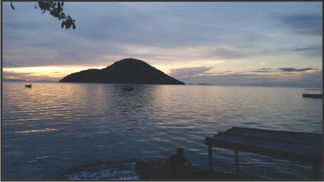

Introducing Chief Madodhi’s Children’s School and Feeding Fund
In Chembe Village on the shores of Cape Maclear (Monkey Bay, Mangochi), families work hard to give their children a brighter future.
Together with Chief Madodhi and community members Robert Matewere and William his nephew, we are launching the Chief Madodhi’s Children’s School and Feeding Fund to meet two urgent needs: keeping children in school and making sure they don’t learn on an empty stomach.

What your support does
- Covers children’s school fees so learners can enrol and stay in class—along with essentials like uniforms, exercise books, pens, and exam fees.
- Run a simple, reliable feeding program that provides nutritious meals sourced from local markets, improving concentration, attendance, and health.

Community-led, transparent, and accountable
This initiative is locally guided by Mr Robert Matewere, and William his nephew, with community volunteers tracking beneficiaries, receipts, and meal schedules. We’ll share straightforward updates— how many learners are covered, how many meals served, and a plain-language summary of costs—so every donor can see their impact.

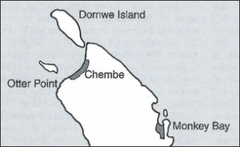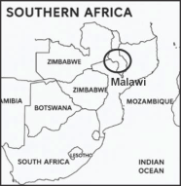
Here’s a map highlighting Chembe (Cape Maclear) and its surroundings on the Nankumba Peninsula— showing the general layout of the land and lake, including village areas, shoreline, and nearby topography.

How to help
A small contribution goes a long way in Chembe Village. Monthly donations keep learners in school and meals on the table; once-off donations help us respond to urgent gaps. If you can’t give, please share this appeal with someone who might.

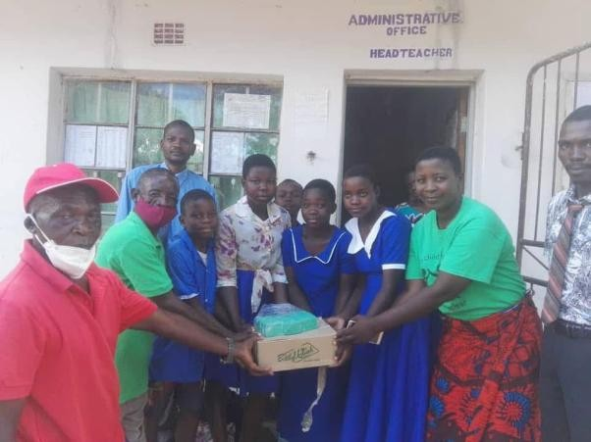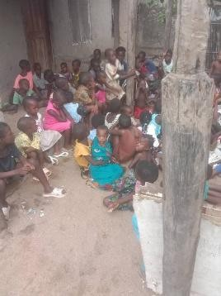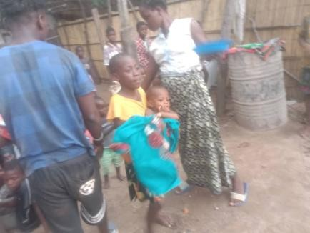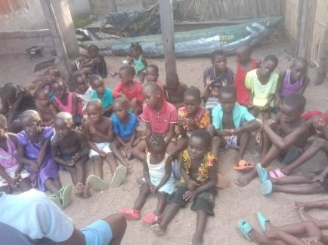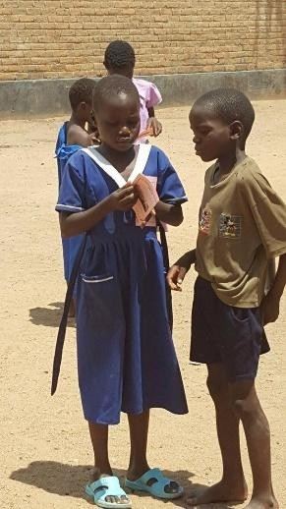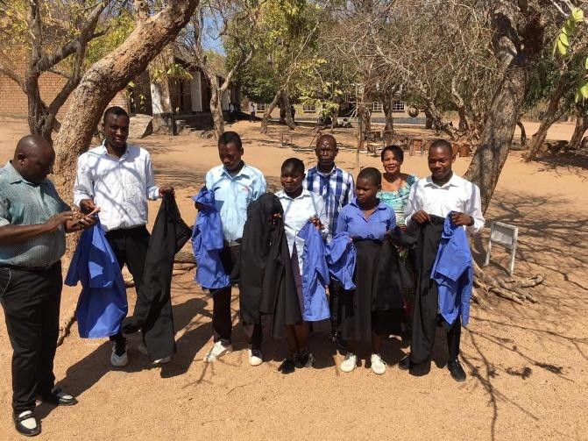

Together, we can turn consistent support into consistent opportunity—one set of school fees and one meal at a me.
Donations can be made to Mr Robert Matewere or Mike Tanton either via Western Union or directly to their bank accounts as detailed below:

The Madodhi Children’s School and Feeding Fund

Fund administrator/director Mr Robert Matewere
ID No: GA6VK7YX
Cell: +265 0995601716

Acc. Name: Robert Matewere
Bank: FDH Bank Malawi
Acc. Number: 1260000097824
FDH SWIFT Code: FDHFMWMW
FDH Monkey Bay Branch Code: FDHFMWMWXXX
Routing/Sort Code: 110001
Zip Code Monkey Bay: 301109

Western Union – MTCN Code (sent to) Cell: +265 0995601716 Mr Robert Matewere
ID No: GA6VK7YX

Address
Mr Robert Matewere’s House Community Road
Chembe Village
Cape Maclear
Monkey Bay
ZIP (Postal Code: 301109)
Mangotchi Region
Malawi

Or

Acc. Name: Mike Tanton
Bank: FDH Bank Malawi
Acc. Number: 1260100137343
FDH SWIFT Code: FDHFMWMW
FDH Monkey Bay Branch Code: FDHFMWMWXXX
Routing/Sort Code: 110001
Zip Code Monkey Bay: 301109

Western Union – MTCN Code (sent to) Cell: +27 079 032 0406 Mike Tanton
ID No: 6710185144084

Or in South Africa…..

Acc. Name: Mike Tanton
Bank: ABSA Bank
Acc. Name: Mike Tanton
Acc. Number: 9336094130

Thank you so much for your support……

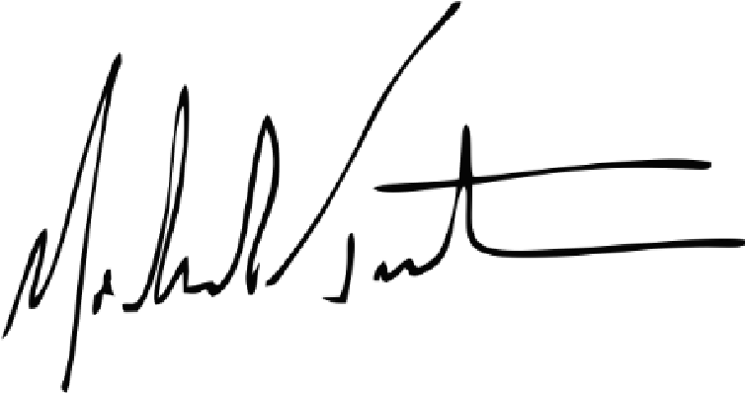
Email: adinehogan2021@gmail.com or mike@rhythmtradingco.com

